COLLEGE OF ENGINEERING AND TECHNOLOGY

Name: Paul Angelo R. Adoremos
Course/Yr/Section: BSIT – 2D
Title of Assignment: Side Menu Bar

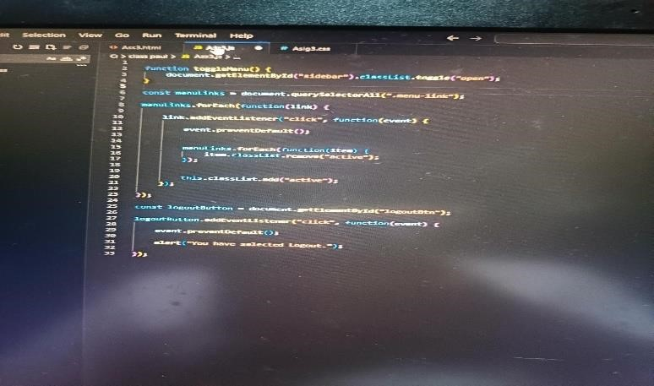






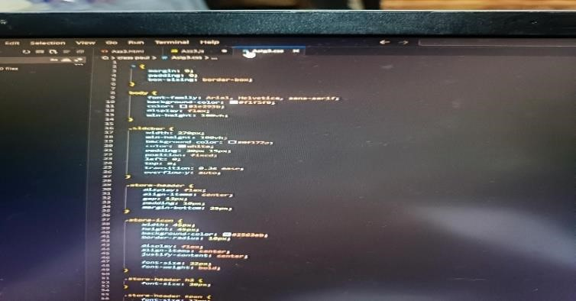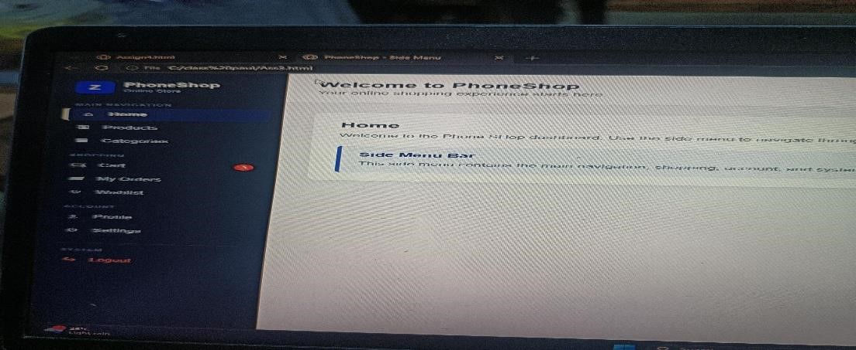

https://github.com/padoremos2022578-cloud/--ADOREMOS_E-COMMERCE.git

